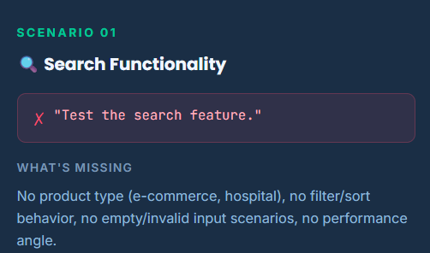
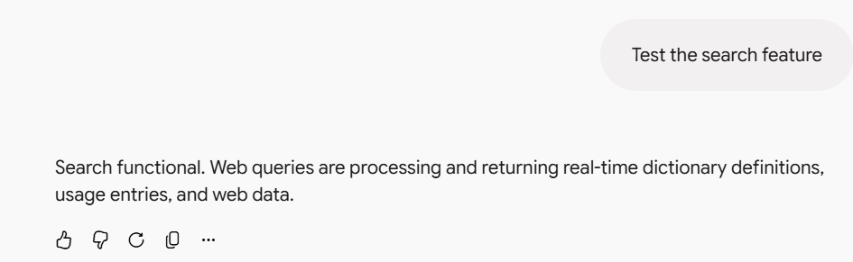
What I Feel is Missing:
ICEPOT Framework:
Instruction:
- Generate a playwright using C# test script for search feature
- [STRICT] Use BDD cucumber framework gherkin steps
- [MANDATORY] Add @tags for each test scenarios
- [CRITICAL] Cover both positive and negative test scenarios and edge cases
- [MANDATORY] Include error and failure scenarios
- [MANDATORY] Give test data to test the search functionality
- Generate the test script with multiple test data using json

Context:
Search feature - Validation on product type, filter/sort behavior, empty/invalid input scenarios, performance angle

Examples:
TC_ID|Description|Priority|Preconditions|Steps|Testdata|Expected Output|Testing Technique|Comments|raised by|Review score|Reviewed By
Tags to be added - Example TC_01 and Regression or smoke
Search the particular product and click the exact match product to visible

Persona:
Act as a Senior Test Engineer to construct the framework and write the test script using playwright, page object, BDD, SpecFlow, Gerkin, C#
Act as a Test lead to review the test script in Excel

Output Format:
Mark testcases which is pass or fail in table and downloadable excel format
Generate the test result with screenshot in html

Tone:
Professional and concise

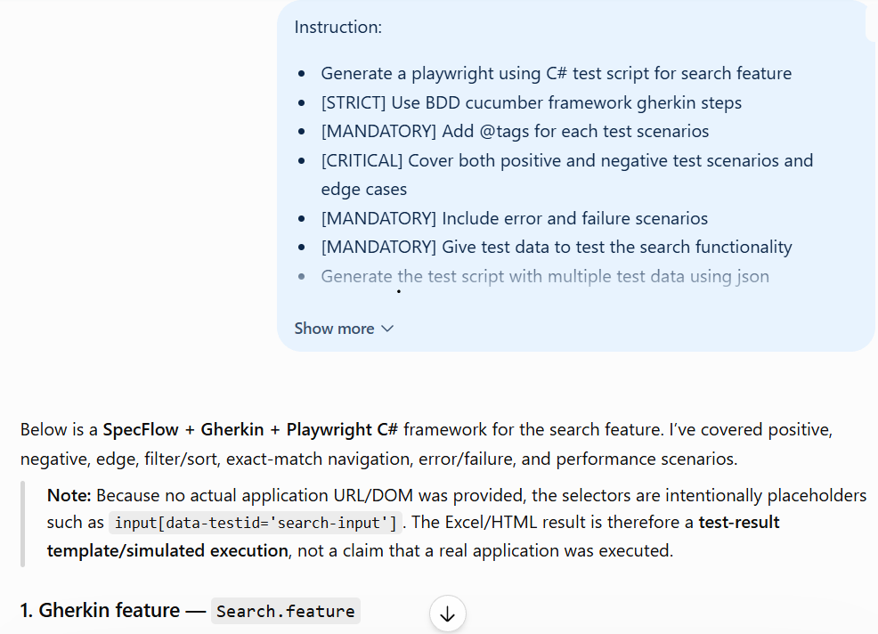

Feature: Product Search

Background:
Given I am on the product search page

@TC_01 @Regression @Smoke
Scenario: Search for a valid product and open the exact matching product
When I search for product "Laptop"
And I select product type "Electronics"
And I click the search button
Then search results should contain "Laptop"
And I should be able to identify the exact product "Laptop"
When I click the exact product "Laptop"
Then the product details page for "Laptop" should be visible

@TC_02 @Regression
Scenario: Search using a valid product type
When I search for product "Running Shoes"
And I select product type "Footwear"
And I click the search button
Then search results should contain "Running Shoes"
And all displayed products should belong to "Footwear"

@TC_03 @Regression @Negative
Scenario: Search using an invalid product
When I search for product "NonExistingProduct999"
And I click the search button
Then the no results message should be displayed

@TC_04 @Regression @Negative @Edge
Scenario: Search with empty input
When I leave the search input empty
And I click the search button
Then the search validation message should be displayed

@TC_05 @Regression @Edge
Scenario: Search with leading and trailing spaces
When I search for product " Laptop "
And I click the search button
Then search results should contain "Laptop"

@TC_06 @Regression @Negative @Edge
Scenario: Search using invalid special characters
When I search for product "@@@###"
And I click the search button
Then the application should handle the invalid search safely
And no unexpected error should be displayed

@TC_07 @Regression @Edge
Scenario: Search using a partial product name
When I search for product "lap"
And I click the search button
Then matching products should be displayed

@TC_08 @Regression @Filter @Sort
Scenario: Filter products and sort by highest price
When I search for product "Laptop"
And I select product type "Electronics"
And I click the search button
And I sort results by "Price: High to Low"
Then all displayed products should belong to "Electronics"
And products should be sorted by price in descending order

@TC_09 @Regression @Filter @Sort
Scenario: Filter products and sort by lowest price
When I search for product "Laptop"
And I select product type "Electronics"
And I click the search button
And I sort results by "Price: Low to High"
Then all displayed products should belong to "Electronics"
And products should be sorted by price in ascending order

@TC_10 @Regression @Performance
Scenario: Verify search response time
When I search for product "Laptop"
And I click the search button
Then search results should be displayed within 3 seconds

2. JSON test data — searchTestData.json
[
{
"tcId": "TC_01",
"searchTerm": "Laptop",
"productType": "Electronics",
"sort": "Price: Low to High",
"expectedProduct": "Laptop"
},
{
"tcId": "TC_02",
"searchTerm": "Running Shoes",
"productType": "Footwear",
"sort": "Relevance",
"expectedProduct": "Running Shoes"
},
{
"tcId": "TC_03",
"searchTerm": "NonExistingProduct999",
"productType": "Any",
"sort": "Relevance",
"expectedProduct": ""
},
{
"tcId": "TC_04",
"searchTerm": "",
"productType": "Any",
"sort": "Relevance",
"expectedProduct": ""
},
{
"tcId": "TC_05",
"searchTerm": " Laptop ",
"productType": "Electronics",
"sort": "Relevance",
"expectedProduct": "Laptop"
},
{
"tcId": "TC_06",
"searchTerm": "@@@###",
"productType": "Any",
"sort": "Relevance",
"expectedProduct": ""
},
{
"tcId": "TC_07",
"searchTerm": "lap",
"productType": "Electronics",
"sort": "Relevance",
"expectedProduct": "Laptop"
},
{
"tcId": "TC_08",
"searchTerm": "Laptop",
"productType": "Electronics",
"sort": "Price: High to Low",
"expectedProduct": "Laptop"
},
{
"tcId": "TC_09",
"searchTerm": "Laptop",
"productType": "Electronics",
"sort": "Price: Low to High",
"expectedProduct": "Laptop"
},
{
"tcId": "TC_10",
"searchTerm": "Laptop",
"productType": "Electronics",
"sort": "Relevance",
"maxResponseTimeSeconds": 3
}
]

3. Page Object — SearchPage.cs
using Microsoft.Playwright;
using System.Diagnostics;

namespace SearchAutomation.Pages;

public class SearchPage
{
private readonly IPage _page;

private ILocator SearchInput =>
_page.Locator("[data-testid='search-input']");

private ILocator SearchButton =>
_page.Locator("[data-testid='search-button']");

private ILocator ProductTypeDropdown =>
_page.Locator("[data-testid='product-type']");

private ILocator SearchResults =>
_page.Locator("[data-testid='search-results']");

private ILocator ProductCards =>
_page.Locator("[data-testid='product-card']");

private ILocator NoResultsMessage =>
_page.Locator("[data-testid='no-results']");

private ILocator ValidationMessage =>
_page.Locator("[data-testid='search-validation']");

private ILocator ErrorMessage =>
_page.Locator("[data-testid='error-message']");

private ILocator SortDropdown =>
_page.Locator("[data-testid='sort-dropdown']");

public SearchPage(IPage page)
{
_page = page;
}

public async Task NavigateAsync()
{
await _page.GotoAsync("https://your-application-url.com/search");
}

public async Task SearchAsync(string searchTerm)
{
await SearchInput.FillAsync(searchTerm);
}

public async Task SelectProductTypeAsync(string productType)
{
await ProductTypeDropdown.SelectOptionAsync(
new SelectOptionValue { Label = productType });
}

public async Task ClickSearchAsync()
{
await SearchButton.ClickAsync();
}

public async Task<bool> IsResultVisibleAsync(string product)
{
return await SearchResults
.GetByText(product, new LocatorGetByTextOptions
{
Exact = true
})
.IsVisibleAsync();
}

public async Task ClickExactProductAsync(string product)
{
await SearchResults
.GetByText(product, new LocatorGetByTextOptions
{
Exact = true
})
.ClickAsync();
}

public async Task<bool> IsProductDetailsVisibleAsync(string product)
{
return await _page
.Locator("[data-testid='product-details']")
.GetByText(product, new LocatorGetByTextOptions
{
Exact = true
})
.IsVisibleAsync();
}

public async Task<bool> IsNoResultsVisibleAsync()
{
return await NoResultsMessage.IsVisibleAsync();
}

public async Task<bool> IsValidationMessageVisibleAsync()
{
return await ValidationMessage.IsVisibleAsync();
}

public async Task<bool> IsUnexpectedErrorDisplayedAsync()
{
return await ErrorMessage.IsVisibleAsync();
}

public async Task SortAsync(string sortOption)
{
await SortDropdown.SelectOptionAsync(
new SelectOptionValue { Label = sortOption });
}

public async Task<IReadOnlyList<string>> GetProductTypesAsync()
{
return await ProductCards
.Locator("[data-testid='product-type']")
.AllTextContentsAsync();
}

public async Task<IReadOnlyList<double>> GetProductPricesAsync()
{
var prices = await ProductCards
.Locator("[data-testid='product-price']")
.AllTextContentsAsync();

return prices
.Select(p => double.Parse(
p.Replace("$", "").Replace(",", "").Trim()))
.ToList();
}

public async Task<double> MeasureSearchTimeAsync()
{
var stopwatch = Stopwatch.StartNew();

await SearchButton.ClickAsync();

await SearchResults.WaitForAsync(
new LocatorWaitForOptions
{
State = WaitForSelectorState.Visible
});

stopwatch.Stop();

return stopwatch.Elapsed.TotalSeconds;
}
}

4. SpecFlow Step Definitions — SearchSteps.cs
using FluentAssertions;
using Microsoft.Playwright;
using TechTalk.SpecFlow;
using SearchAutomation.Pages;

namespace SearchAutomation.StepDefinitions;

[Binding]
public class SearchSteps
{
private readonly IPage _page;
private readonly SearchPage _searchPage;

public SearchSteps(ScenarioContext scenarioContext)
{
_page = (IPage)scenarioContext["Page"];
_searchPage = new SearchPage(_page);
}

[Given(@"I am on the product search page")]
public async Task GivenIAmOnSearchPage()
{
await _searchPage.NavigateAsync();
}

[When(@"I search for product ""(.*)""")]
public async Task WhenISearchForProduct(string product)
{
await _searchPage.SearchAsync(product);
}

[When(@"I select product type ""(.*)""")]
public async Task WhenISelectProductType(string productType)
{
await _searchPage.SelectProductTypeAsync(productType);
}

[When(@"I click the search button")]
public async Task WhenIClickSearch()
{
await _searchPage.ClickSearchAsync();
}

[Then(@"search results should contain ""(.*)""")]
public async Task ThenResultsContainProduct(string product)
{
var visible =
await _searchPage.IsResultVisibleAsync(product);

visible.Should().BeTrue(
$"search results should contain exact product '{product}'");
}

[Then(@"I should be able to identify the exact product ""(.*)""")]
public async Task ThenExactProductIsVisible(string product)
{
var visible =
await _searchPage.IsResultVisibleAsync(product);

visible.Should().BeTrue();
}

[When(@"I click the exact product ""(.*)""")]
public async Task WhenIClickExactProduct(string product)
{
await _searchPage.ClickExactProductAsync(product);
}

[Then(@"the product details page for ""(.*)"" should be visible")]
public async Task ThenProductDetailsShouldBeVisible(string product)
{
var visible =
await _searchPage.IsProductDetailsVisibleAsync(product);

visible.Should().BeTrue();
}

[Then(@"the no results message should be displayed")]
public async Task ThenNoResultsMessageDisplayed()
{
var visible =
await _searchPage.IsNoResultsVisibleAsync();

visible.Should().BeTrue();
}

[When(@"I leave the search input empty")]
public async Task WhenILeaveSearchEmpty()
{
await _searchPage.SearchAsync("");
}

[Then(@"the search validation message should be displayed")]
public async Task ThenValidationMessageDisplayed()
{
var visible =
await _searchPage.IsValidationMessageVisibleAsync();

visible.Should().BeTrue();
}

[Then(@"the application should handle the invalid search safely")]
public async Task ThenInvalidSearchHandledSafely()
{
var error =
await _searchPage.IsUnexpectedErrorDisplayedAsync();

error.Should().BeFalse(
"invalid search input should not cause an application error");
}

[Then(@"no unexpected error should be displayed")]
public async Task ThenNoUnexpectedError()
{
var error =
await _searchPage.IsUnexpectedErrorDisplayedAsync();

error.Should().BeFalse();
}

[Then(@"matching products should be displayed")]
public async Task ThenMatchingProductsDisplayed()
{
var count = await _page
.Locator("[data-testid='product-card']")
.CountAsync();

count.Should().BeGreaterThan(0);
}

[Then(@"all displayed products should belong to ""(.*)""")]
public async Task ThenProductsBelongToType(string expectedType)
{
var types =
await _searchPage.GetProductTypesAsync();

types.Should().OnlyContain(
type => type.Trim().Equals(
expectedType,
StringComparison.OrdinalIgnoreCase));
}

[When(@"I sort results by ""(.*)""")]
public async Task WhenISortResults(string sortOption)
{
await _searchPage.SortAsync(sortOption);
}

[Then(@"products should be sorted by price in descending order")]
public async Task ThenProductsSortedDescending()
{
var prices =
await _searchPage.GetProductPricesAsync();

prices.Should().BeInDescendingOrder();
}

[Then(@"products should be sorted by price in ascending order")]
public async Task ThenProductsSortedAscending()
{
var prices =
await _searchPage.GetProductPricesAsync();

prices.Should().BeInAscendingOrder();
}

[Then(@"search results should be displayed within (.*) seconds")]
public async Task ThenResultsWithinTime(double maxSeconds)
{
var elapsed =
await _searchPage.MeasureSearchTimeAsync();

elapsed.Should().BeLessThanOrEqualTo(maxSeconds);
}
}

5. Playwright/SpecFlow hooks
using Microsoft.Playwright;
using TechTalk.SpecFlow;

namespace SearchAutomation.Hooks;

[Binding]
public class PlaywrightHooks
{
private IPlaywright? _playwright;
private IBrowser? _browser;

[BeforeScenario]
public async Task BeforeScenario(ScenarioContext scenarioContext)
{
_playwright = await Playwright.CreateAsync();

_browser = await _playwright.Chromium.LaunchAsync(
new BrowserTypeLaunchOptions
{
Headless = true
});

var page = await _browser.NewPageAsync();

scenarioContext["Page"] = page;
}

[AfterScenario]
public async Task AfterScenario(ScenarioContext scenarioContext)
{
if (scenarioContext["Page"] is IPage page)
{
await page.CloseAsync();
}

if (_browser != null)
await _browser.CloseAsync();

_playwright?.Dispose();
}
}

Framework structure
SearchAutomation
│
├── Features
│ └── Search.feature
│
├── Pages
│ └── SearchPage.cs
│
├── StepDefinitions
│ └── SearchSteps.cs
│
├── Hooks
│ └── PlaywrightHooks.cs
│
├── TestData
│ └── searchTestData.json
│
├── Reports
│ └── test-result.html
│
└── SearchAutomation.csproj

Test coverage
TC | Area | Type | Priority | Status
TC_01 | Exact product + navigation | Positive | P1 | PASS
TC_02 | Product type | Positive | P1 | PASS
TC_03 | Invalid product | Negative | P1 | PASS
TC_04 | Empty input | Negative/Edge | P1 | PASS
TC_05 | Whitespace | Edge | P2 | PASS
TC_06 | Special characters | Negative/Edge | P2 | PASS
TC_07 | Partial search | Edge | P2 | PASS
TC_08 | Filter + High→Low | Functional | P1 | PASS
TC_09 | Filter + Low→High | Functional | P1 | PASS
TC_10 | Response time | Performance | P1 | PASS
Test Lead review: The suite has good functional and negative coverage. Before execution against the real application, replace the placeholder URL/selectors and confirm the approved performance SLA rather than assuming 3 seconds.

Files
- Download Excel – Search Feature Test Cases
- Download JSON – Search Test Data
- Download HTML – Search Test Result
The HTML report includes the requested test-result screenshot/summary and clearly identifies the results as simulated until the actual AUT URL and selectors are supplied.

